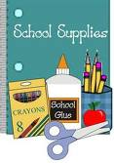
First Grade School Supply Checklist

- Backpack (large enough to hold a folder and other items)
- Book baggie from last year, if you do not have one we will make it available for purchase.
- A complete change of clothes including underwear, socks, shirt, and pants. If your child needs it. Please label all items and place it in a Ziploc bag with your child’s name.
- 1 purple 1 inch View binder
- 4-plastic pocket folders (red, yellow, blue, green)
- 2 Plastic H.W. folders (can be whatever design you like)
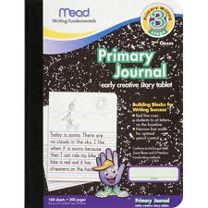
- 3 boxes – 12 ct number 2 Ticonderoga pencils sharpened
- 2 Mead Primary Journals (refer to picture )
- 4 glue sticks
- 1 box of Crayola 24ct crayons
- 1 boxes of Crayola 24ct color pencils
- 1 boxes of Crayola classic 10ct Big Washable markers
- 2 box of Tissues
- 2 rolls of paper towels
- 1 box of gallon Ziploc
- 1 box of sandwich Ziploc
- 1 small container of hand sanitizer or hand soap (optional)
- 2 Clorox/Lysol wipes
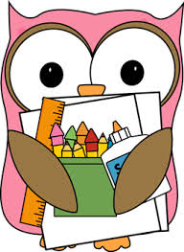
- 2 packs of dry erase markers
- 1 mini dry eraser
- 1 (5 pack) of 3M post its
- 1 role of packing tape
- 1 pack of Paper Mate Flair Pens (black or multicolored)
- 1 pack Hi Polymer Erasers
- 1 pack of the 3-count BIC 4-color ball pens

** All folders, notebooks, backpacks, and complete change of clothes must be sent in on the first day of school.**

